**Railway Management System**

# Problem Statement :A database to keep record of train timings and tracking the routes of trains. Moreover, keeping track of the total number of seats, the number of seats available and the price of each type of ticket while also keeping record of all the passengers and their type of ticket.

**Entity-Relationship Diagram**

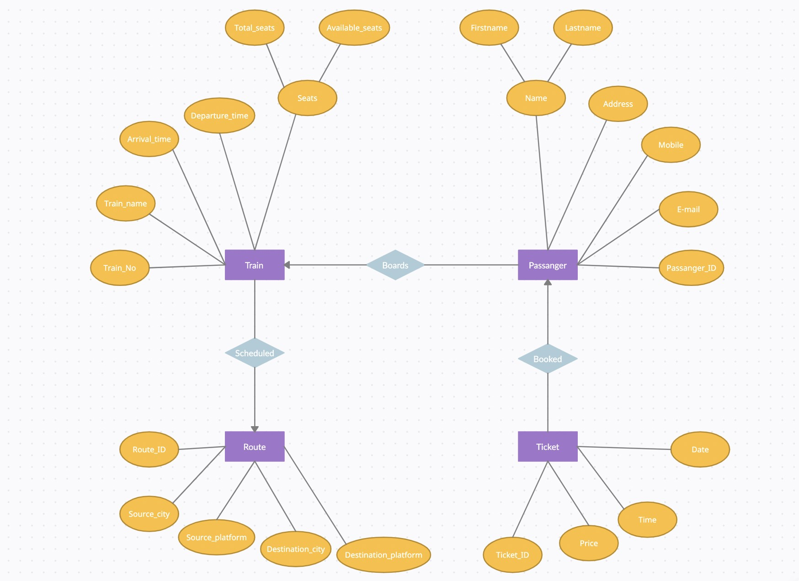

# ER Diagram to Table

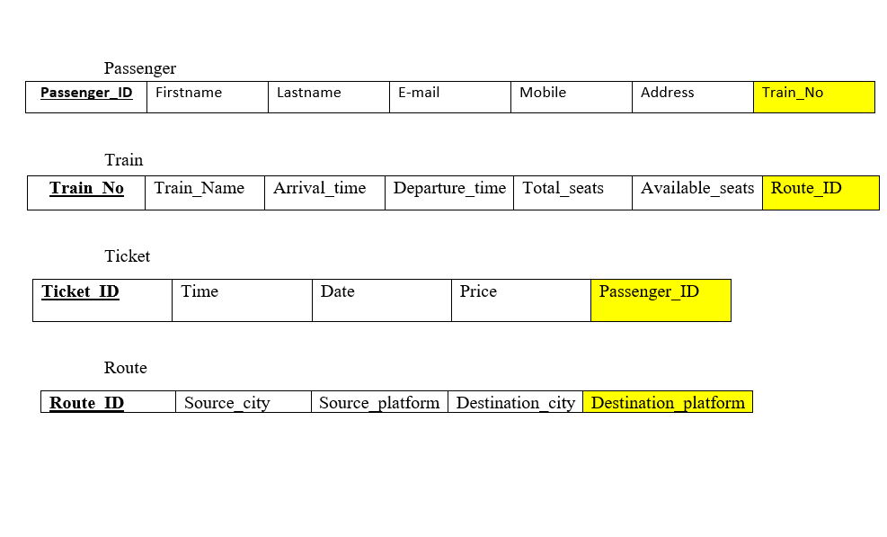

**Normalized Table**

Ticket Table

|  |  |  |  |  |  |  |  |  |  |  |  |  |  |  |  |
| --- | --- | --- | --- | --- | --- | --- | --- | --- | --- | --- | --- | --- | --- | --- | --- |
| Ticket_ID | | | Time |  | | Date | | | |  | Price |  | Passenger_ID | | |
| Passenger Table | | | |  | |  | | | |  | |  | | | |
| Passenger_ ID | | First  name | |  | Last  name |  | | E-mail |  | Mobile | | Address | | Train_No | |
| Train Table | | | |  | |  | | | |  | |  | | | |
| Train_No | Train_ name | | | Arrival_ time | |  | Departure_ time | | |  | Total_ seats | Available_ seats | | | Route_ ID |
| Route Table | | | |  | |  | | | |  | |  | | | |
| Route_ID | | | Source_city | | | Source_ platform | | | |  | Destination_ city | | Destination_ platform | | |

**Creating Table**

create table Route(Route_ID int primary key,

Source_city varchar(20),

Source_platform int,

Destination_city varchar(20), Destination_platform int);

create table Train(Train_No int primary key,

Train_name varchar(20),

Arrival_time timestamp,

Departure_time timestamp,

Total_seats int,

Available_seats int,

Route_ID int,

CONSTRAINT FK_Route_ID FOREIGN KEY (Route_ID) REFERENCES Route(Route_ID));

create table Passenger(Passenger_ID int primary key,

Firstname varchar(20),

Lastname varchar(20),

Email varchar(30),

Mobile number(10),

Address varchar(50),

Train_No int,

CONSTRAINT FK_Train_No FOREIGN KEY (Train_No) REFERENCES Train(Train_No));

create table Ticket(Ticket_ID int primary key,

Train_time timestamp,

Train_date date,

Price number(10),

Passenger_ID int,

CONSTRAINT FK_Passenger_ID FOREIGN KEY (Passenger_ID)

REFERENCES Passenger(Passenger_ID));

# Inserting data in the Table

INSERT INTO Route VALUES(1, 'Delhi', 3, 'Patiala', 5);

INSERT INTO Route VALUES(2, 'Hyderabad', 7, 'Vishakapatnam', 1);

INSERT INTO Route VALUES(3, 'Ahmedabad', 1, 'Bhopal', 2);

INSERT INTO Route VALUES(4, 'Delhi', 5, 'Amritsar', 3);

INSERT INTO Route VALUES(5, 'Chennai', 2, 'Bengluru', 4);

Select * from Route;

INSERT INTO Train VALUES(14507, DLI FKA EXP ','6-Jun-2022 01:05:00pm','6-Jun-2022

06:19:00pm',700,543,1);

INSERT INTO Train VALUES(12704,'Falaknuma Exp','12-May-2022 03:55:00pm','13-Jan2022 04:40:00am',1000,743,2);

INSERT INTO Train VALUES(19413,  ADI KOLKATA EXP ,'21-May-2022 09:05:00pm','22-May-2022 08:25:00am',500,197,3);

INSERT INTO Train VALUES(12497,'Shane Punjab','7-May-2022 06:40:00am','7-May-2022

02:15:00am',800,554,4);

INSERT INTO Train VALUES(12007,'MYS Shatabdi','27-May-2022 06:00:00am','27-May-2022 10:45:00am',400,154,5);

Select * from Train;

INSERT INTO Passenger VALUES(101, 'Ananya, 'Nathi', 'ananya11@gmail.com', 9345655123, 'Kukatpally, Hyderabad', 14507);

INSERT INTO Passenger VALUES(145, 'Srishti', 'Rawat', 'srishtir@gmail.com', 9347367890, 'Kashipur, Uttrakand', 19413);

INSERT INTO Passenger VALUES(332, 'Neeraj', 'Garg', 'ngarg@gmail.com', 7128311223,

'Ashok Vihar, Punjab', 12704);

INSERT INTO Passenger VALUES(201, 'Hiten', 'Narang', 'hitenn1@gmail.com', 9876543421,

'Bhadson road, Patiala', 12007);

INSERT INTO Passenger VALUES(443, 'Nishanth', 'Verma', 'nishanth13@gmail.com', 7865234591,'Chennai', 12497);

Select * from Passenger;

INSERT INTO Ticket VALUES(3519545764,'25-April-2022 03:20:00pm','25-April-2022',1000, 145);

INSERT INTO Ticket VALUES(2347812334,'10-July-2022 08:30:00pm','10-July-2022',1500, 101);

INSERT INTO Ticket VALUES(1235678321,'19-Jun-2022 10:50:00pm','19-Jun-2022',1150, 201);

INSERT INTO Ticket VALUES(156712901,'22-May-2022 11:40:30pm','22-May-2022',550, 443);

INSERT INTO Ticket VALUES(1421621421,'05-Jan-2022 09:35:00am','18-Jan-2022',900, 332);

Select * from Ticket;

**SQL Output Screenshots**

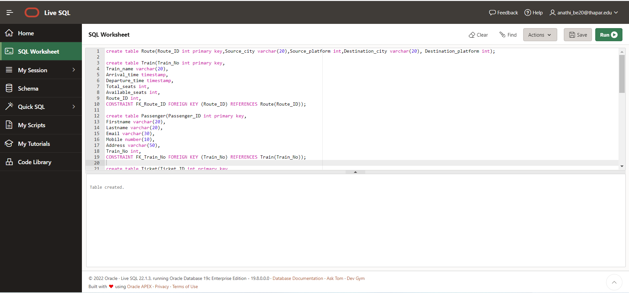 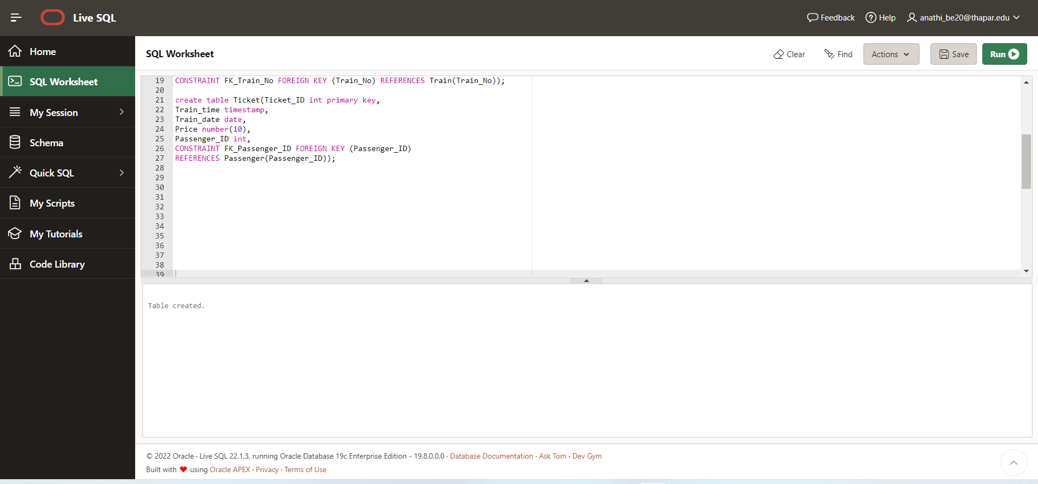

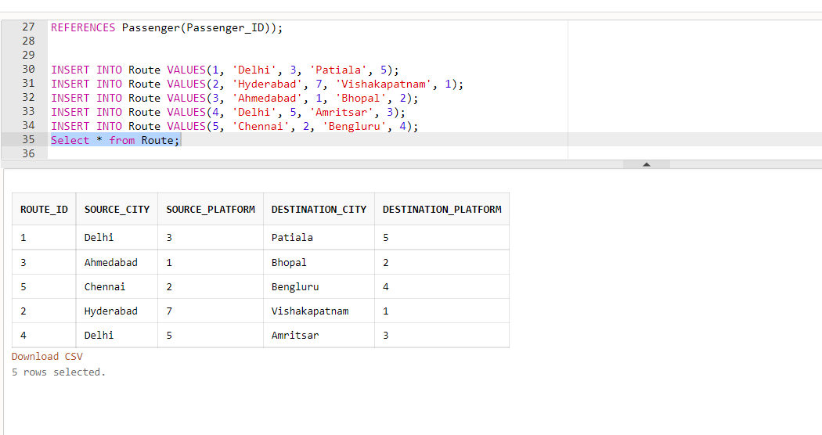

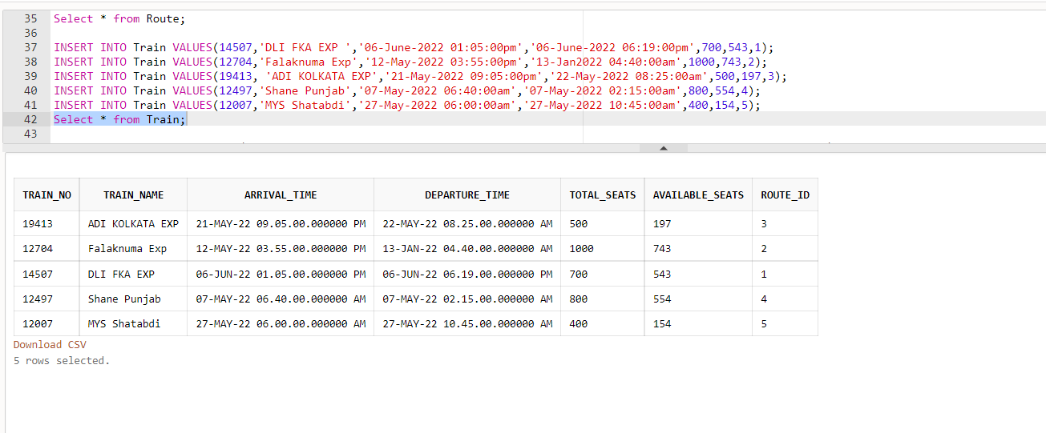

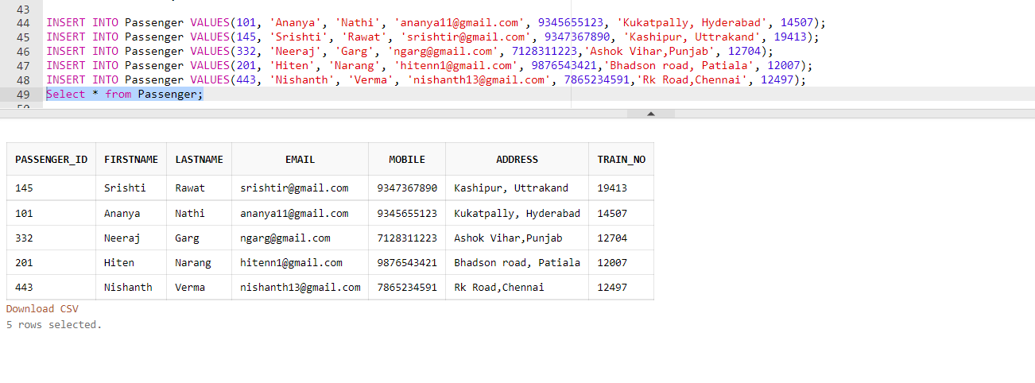

**PL/SQL Codes and Screenshots**

## 1. To display details of all passengers

Declare

P_Firstname Passenger.Firstname%type;

P_Lastname Passenger.Lastname%type;

Mobile Passenger.Mobile%type;

Address Passenger.Address%type;

Cursor c IS select Firstname,Lastname,Mobile,Address from Passenger; Begin open c; loop fetch c into P_Firstname,P_Lastname,Mobile,Address; exit when c%NOTFOUND;

dbms_output.put_line(P_Firstname||' '||P_Lastname||' '||Mobile||' '||Address); end loop; close c; end;

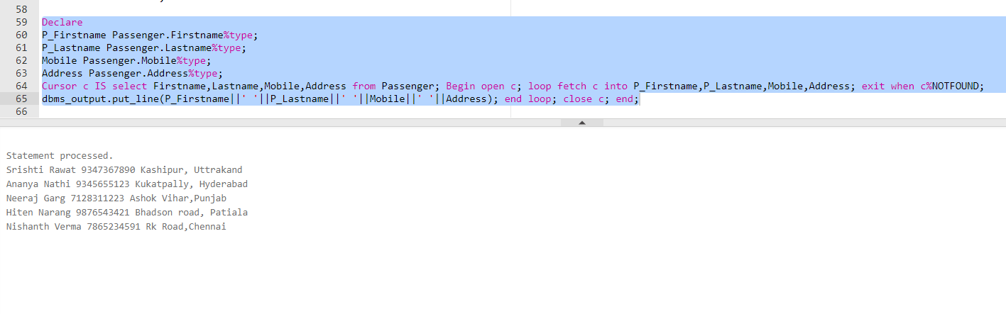

## 2. To display the details of passenger whose has taken highest fair ticket

declare

P_Firstname Passenger.Firstname%type;

P_Lastname Passenger.Lastname%type;

Mobile Passenger.Mobile%type;

Address Passenger.Address%type;

CustomerId Passenger.Passenger_ID%type;

Cursor c IS select P.Firstname,P.Lastname,P.Mobile,P.Address,T.Passenger_ID from

Passenger P,Ticket T where

Price=(select max(Price) from Ticket) and T.Passenger_ID=P.Passenger_ID; begin open c; loop fetch c into

P_Firstname,P_Lastname,Mobile,Address,CustomerId; exit when c%NOTFOUND;

dbms_output.put_line(P_Firstname||' '||P_Lastname||' '||Mobile||' '||Address||'

'||CustomerId||' '); end loop; close c; end;

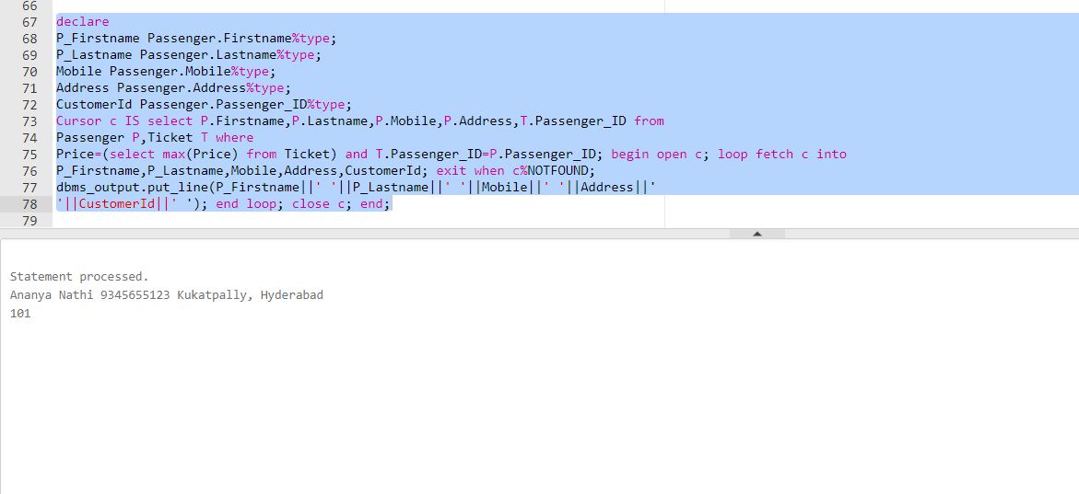

## 3.To display the details of passenger whose train is in evening declare

declare

P_Firstname Passenger.Firstname%type;

P_Lastname Passenger.Lastname%type;

Mobile Passenger.Mobile%type;

Address Passenger.Address%type;

Train_No Passenger.Train_No%type;

Cursor c IS select P.Firstname,P.Lastname,P.Mobile,P.Address,T.Train_No from Passenger P,Train T where to_char(T.Arrival_time,'pm')='pm' and T.Train_No=P.Train_No; begin open c; loop fetch c into

P_Firstname,P_Lastname,Mobile,Address,Train_No; exit when c%NOTFOUND;

dbms_output.put_line(P_Firstname||' '||P_Lastname||' '||Mobile||' '||Address||' '||Train_No||'

');

end loop; close c; end;

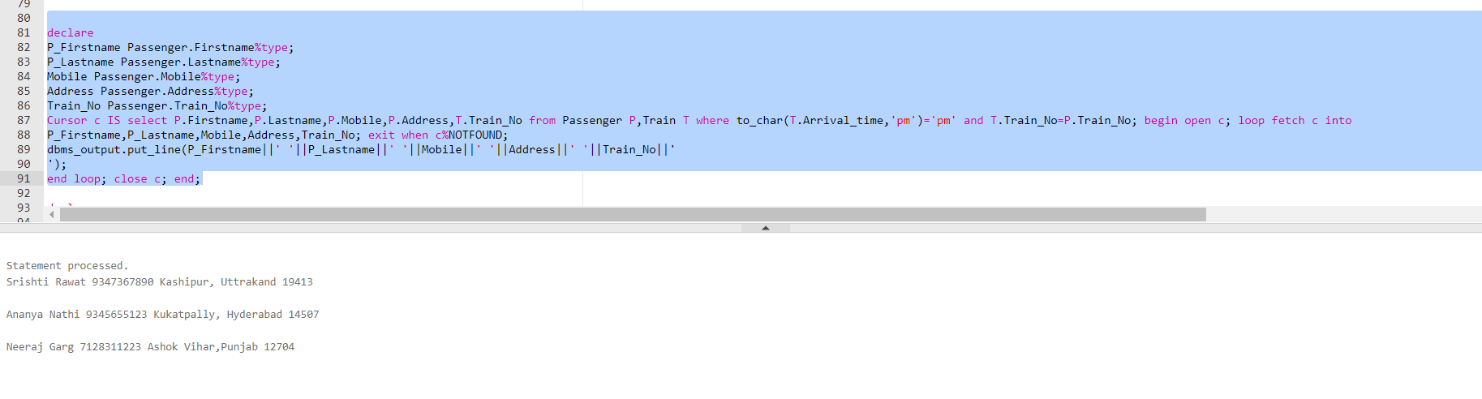

## 4. Exception handling

declare

P_Email Passenger.Email%type; P_Passenger_ID Passenger.Passenger_ID%type; e_invalid_ID EXCEPTION; begin update Passenger set Email = 'random@gmail.com' where P_Passenger_ID = 2; if SQL%NOTFOUND then

raise e_invalid_ID; End if; commit;

EXCEPTION

When no_data_found then dbms_output.put_line('No such record'); When too_many_rown then dbms_output.put_line('More than one record found'); When e_invalid_ID then dbms_output.put_line('No such passenger exists'); When others then dbms_output.put_line('Some error found'); end;

